Data Cleaning & Essential Functions

- What is data cleaning, and why is it important in data analysis? What are the potential consequences of analyzing unclean or messy data? Explain the common steps involved in cleaning and organizing data.

ANS:- Data cleaning is the process of preparing raw data by identifying and correcting errors, removing duplicates, handling missing values,and ensuring consistency and accuracy. It is an essential step in data analysis because the quality of insights and decision depends directly on the quality of the data used.

IMPORTANCE OF DATA CLEANING
- Ensure accurate and reliable analysis
- Improves decision making
- Increases data consistency and usability
- Saves time during analysis and reporting

CONSEQUENCES OF ANALYSING UNCLEAN OR MESSY DATA
- Incorrect or misleading insights
- Wrong business or strategic decisions
- Inaccurate reports and dashboards
- Increased analysis time and cost
- Loss of trust in data result

COMMON STEPS INVOLVED IN CLEANING AND ORGANIZING DATA

- Handlling missing values
- Removing duplicates
- Correcting data type
- Removing duplicates
- Standarizing data
- Fixing errors and inconsistencies
- Validating data

- How would you sort the following dataset first by "Department" (A-Z) and then by "Salary" (Largest to Smallest)? Write a step-by-step approach.

ANS:- Step by step method to sort the data by salary (largest to smallest)

- Select the entire dataset
Highlight all rows and columns includes headers (employee, department, salary).
- Go to the data tab
Click on the data tab in excel ribbon

- Click on sort
In the sort and filter group click ( not A-Z directly).

- Set the first sorting level (department)
In the sort dialogue box:
Sort by: Department
Sort by: Values
Order : A-Z

- Add second sorting level (salary)
Click ADD LEVEL
Then by: Salary
Sort on: values
Order : Largest to Smallest

- Click OK
Excel will apply both sorting rules in order

3. Explain the use of text functions such as TRIM , LEFT, RIGHT, MID, and CONCAT in data cleaning.

ANS:- Text function are very useful in data cleaning because they help fix formatting issues, remove unwanted character, and standardize text data.

TRIM()
USE:
Remove extra spaces from text (leading, trailing, and multiple spaces between words).

Importance of data cleaning
- Fixes issues where names or values look same but contain extra spaces
- Helps avoid duplicate records caused by spacing errors
Example:
=TRIM(“ John Smith “) —> John Smith

LEFT()
USE:
Extract a specified number of characters from the left side of a text string.
Importance
Useful for extracting codes, prefix, or initials

Example:
=LEFT(“EMP12345”, 3) —> EMP

RIGHT()
USE:
Extract characters from the right side of a text string

Importance:
Help extract suffixes, last digits, or year codes

Example:
=RIGHT(“INVOICE2024”,4) —-> 2024

CONCAT()/CONCATENATE()
USE:
Joins two or more text values into one.

IMPORTANCE:
- Combines first name and last name
- Creates full addresses or IDs

Example:
=CONCAT(“John”, “ “ , “Doe”) —> John Doe

MID()
USE:
Extract text from the middle of a string, based on position and length.

IMPORTANCE:
Useful when data is embedded within text (like IDs or phone numbers)

Example:
=MID(“ORD-56789-A”, 5, 5) —-> 56789

4. What is the role of date functions like TODAY in managing datasets?

ANS:- Date function like TODAY() play an important role in managing and analyzing dataset because they help keep data dynamic, up to date, and time based.

ROLE OF TODAY() FUNCTION

TODAY() returns the current date automatically and updates every time the file is opened or recalculated.

Date functions like TODAY() helps in:
- Managing time based data
- Automating calculations
- Keeping reports current
- Improving efficiency and accuracy

5. Apply Data Validation to restrict Quantity values to only whole numbers between 1 and 10.
- Configure an input message that appears when a user selects a cell in the "Quantity" column explaining: "Please enter a whole number between 1 and 10."
- Set up an error alert message that triggers if the user enters a number less than 1 or greater than 10, showing: "Invalid input! The quantity must be a whole number between 1 and 10."
Write a step-by-step approach for this question

ANS: (a) Input Message Setup
- Select the quantity column cell
- Go to data tab and click on Data Validation
- In setting tab:
* Allow: Whole number
* Data: Between
* Minimum: 1
* Maximum: 10
4. Click the Input message tab
5. Tick show input message when cell is selected.
6. Fill the fields:
- Title: Quantity Input
- Input message: “Please enter a whole number between 1 and 10”
7. Click OK
★ Now when a user selects a quantity cell this message will appear

(b) Error Alert setup
- Again open Data Validation
- Go to the error alert tab
- Tick show error alert invalid data is entered
- Set:
- Style: Stop
- Title: Invalid Input
- Error message: “Invalid input! The quantity must be a whole number between 1 and 10”
- Click OK
★Now if the user enters a number less than 1 or greater than 10 or not whole number excel will this error.

8. Understanding TODAY() and NOW()
a. What is the difference between TODAY() and NOW() in Excel? Provide an example of when you would use each function.
b. If cell A1 contains the date 2025-06-10, write a formula using TODAY() to determine how many days are left until that date
c. Write an Excel formula using NOW() to display the current date and time in the format MM/DD/YYYY HH:MM AM/PM. ́
d. If a cell contains =TODAY(), what will happen when the worksheet is reopened the next day? Explain
e. You want to store a static date (today’s date) in a cell without it changing every day. What keyboard shortcut should you use?

ANS: (a) Difference between TODAY() and NOW()
TODAY() → Returns only the current date
Example use: Daily report date, attendance date
NOW() → Returns current date and current time
Example use: Login time, timestamp for data entry
Example formulas:
=TODAY()
=NOW()

(b) Days left until a given date (A1 = 2025-06-10)
Formula:
=A1-TODAY()
Explanation:
Excel subtracts today’s date from the future date and gives the number of days remaining.

(c) Show current date & time (MM/DD/YYYY HH:MM AM/PM)
Formula:
Excel
=NOW()
Then apply Custom Format:

MM/DD/YYYY HH:MM AM/PM

(d) What happens to =TODAY() when the file is opened next day?
👉 The date automatically updates to the new current date, because TODAY() is a volatile function.

(e) Store today’s date permanently (static date)
Keyboard Shortcut (Windows):
Copy code

Ctrl + ;
📌 This inserts today’s date as a fixed value that does not change.

Ans-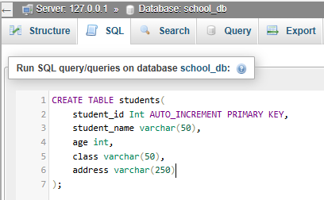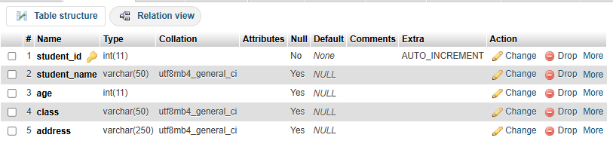

Lab 2: Insert five records into the students table and retrieve all records using the SELECT statement.
Ans-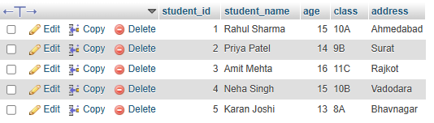
2. SQL Syntax
LAB EXERCISES:
• Lab 1: Write SQL queries to retrieve specific columns (student_name and age) from the students table.
Ans- 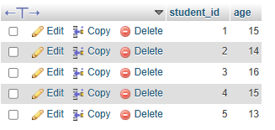
• Lab 2: Write SQL queries to retrieve all students whose age is greater than 10.
Ans- 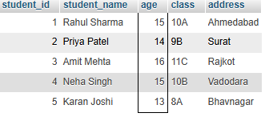
3. SQL Constraints
• Lab 1: Create a table teachers with the following columns: teacher_id (Primary Key), teacher_name (NOT NULL), subject (NOT NULL), and email (UNIQUE).
Ans- 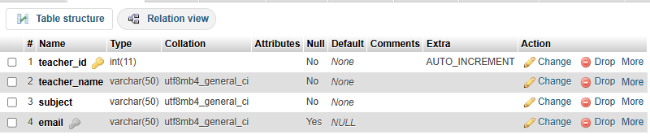
• Lab 2: Implement a FOREIGN KEY constraint to relate the teacher_id from the teachers table with the students table.
Ans-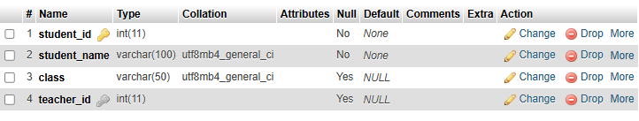
4. Main SQL Commands and Sub-commands (DDL)
LAB EXERCISES:
• Lab 1: Create a table courses with columns: course_id, course_name, and course_credits. Set the course_id as the primary key.
Ans- 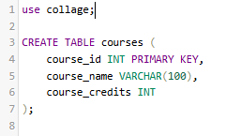
• Lab 2: Use the CREATE command to create a database university_db.
Ans-
5. ALTER Command
LAB EXERCISES:
• Lab 1: Modify the courses table by adding a column course_duration using the ALTER command.
Ans- 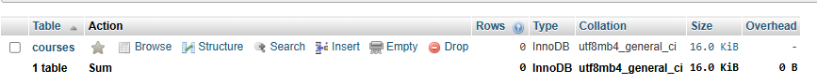
• Lab 2: Drop the course_credits column from the courses table.
Ans- 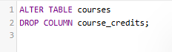
6. DROP Command
LAB EXERCISES:
• Lab 1: Drop the teachers table from the school_db database.
Ans- 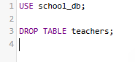

• Lab 2: Drop the students table from the school_db database and verify that the table has been removed.
Ans- 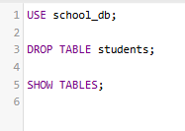
7. Data Manipulation Language (DML)
LAB EXERCISES:
• Lab 1: Insert three records into the courses table using the INSERT command.
Ans- 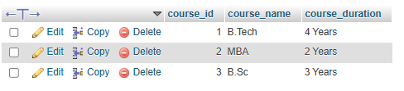
• Lab 2: Update the course duration of a specific course using the UPDATE command.
Ans-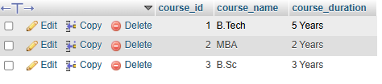
• Lab 3: Delete a course with a specific course_id from the courses table using the DELETE command.
Ans-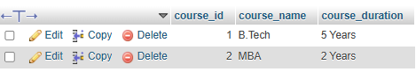

8. Data Query Language (DQL)
LAB EXERCISES:
• Lab 1: Retrieve all courses from the courses table using the SELECT statement.
Ans-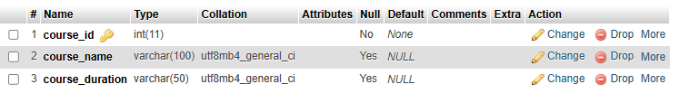
• Lab 2: Sort the courses based on course_duration in descending order using ORDER BY.
Ans-
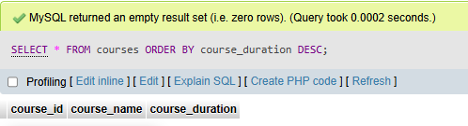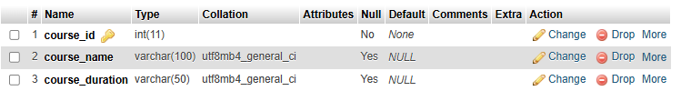
• Lab 3: Limit the results of the SELECT query to show only the top two courses using LIMIT.
Ans-
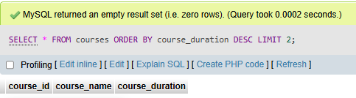
9. Data Control Language (DCL)
Lab 1: Create two new users user1 and user2 and grant user1 permission to SELECT from the courses table.
Ans-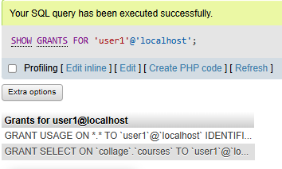
10. Transaction Control Language (TCL)
LAB EXERCISES:
• Lab 1: Insert a few rows into the courses table and use COMMIT to save the changes.
Ans- 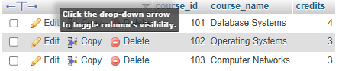
• Lab 2: Insert additional rows, then use ROLLBACK to undo the last insert operation.
Ans- 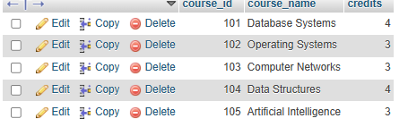
11. SQL Joins
• Lab 1: Create two tables: departments and employees. Perform an INNER JOIN to display employees along with their respective departments.
Ans- 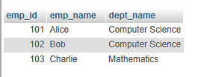

• Lab 2: Use a LEFT JOIN to show all departments, even those without employees.
Ans- 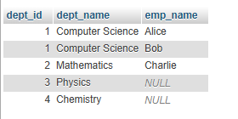
12. SQL Group By
Lab 1: Group employees by department and count the number of employees in each department using GROUP BY.
Ans- 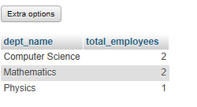
• Lab 2: Use the AVG aggregate function to find the average salary of employees in each department.
Ans- 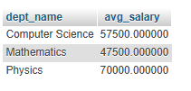
13. SQL Stored Procedure
Lab 1: Write a stored procedure to retrieve all employees from the employees table based on department.
Ans- 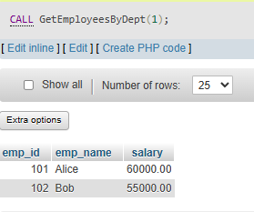
• Lab 2: Write a stored procedure that accepts course_id as input and returns the course details.
Ans- 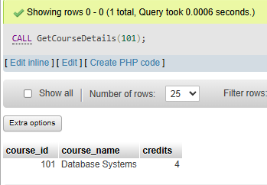
14. SQL View
• Lab 1: Create a view to show all employees along with their department names.
Ans- 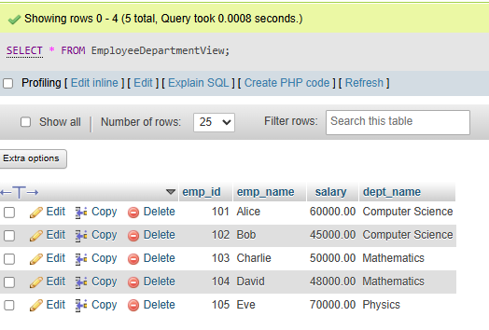

• Lab 2: Modify the view to exclude employees whose salaries are below $50,000.
Ans- 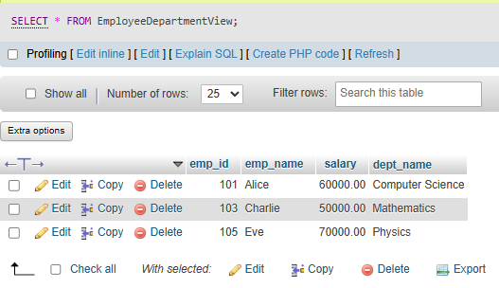
15. SQL Triggers
Lab 1: Create a trigger to automatically log changes to the employees table when a new employee is added.
Ans- 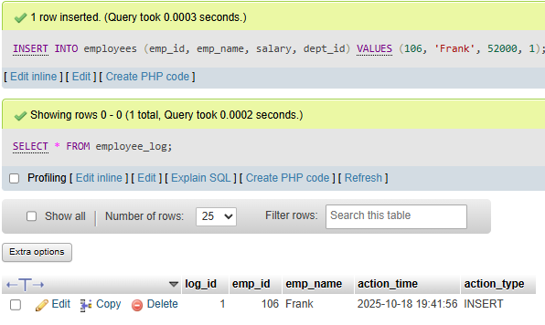
• Lab 2: Create a trigger to update the last_modified timestamp whenever an employee record is updated.
Ans- 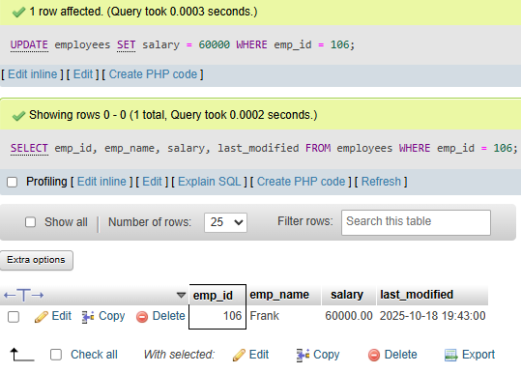

16. Introduction to PL/SQL
• Lab 1: Write a PL/SQL block to print the total number of employees from the employees table.
Ans- 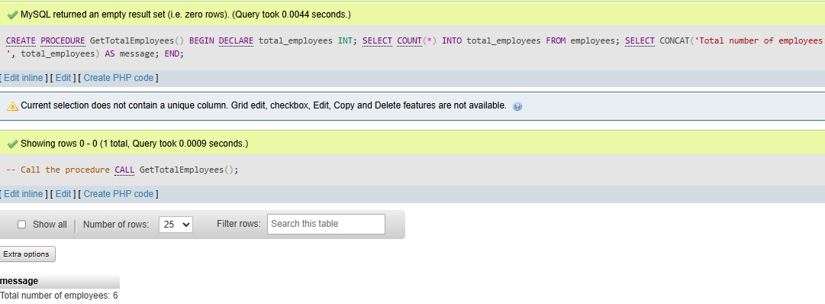
• Lab 2: Create a PL/SQL block that calculates the total sales from an orders table.
Ans- 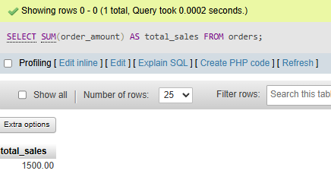
17. PL/SQL Control Structures
Lab 1: Write a PL/SQL block using an IF-THEN condition to check the department of an employee.
Ans- 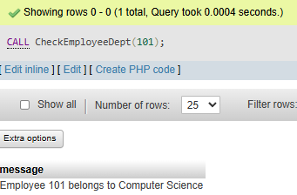
• Lab 2: Use a FOR LOOP to iterate through employee records and display their names.
Ans- 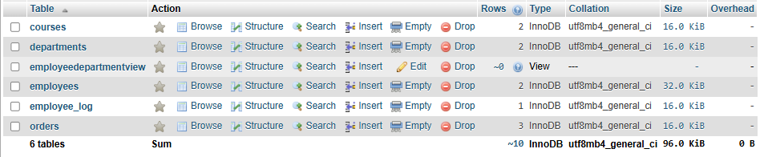
18. SQL Cursors
• Lab 1: Write a PL/SQL block using an explicit cursor to retrieve and display employee details.
Ans-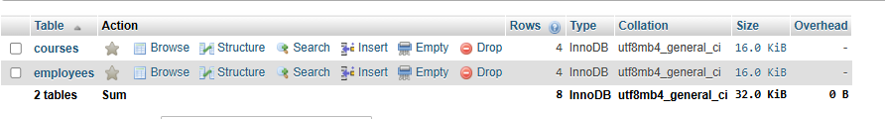
19. Rollback and Commit Savepoint
Lab 1: Perform a transaction where you create a savepoint, insert records, then rollback to the savepoint.
Ans-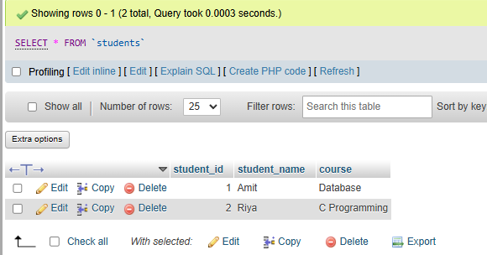
• Lab 2: Commit part of a transaction after using a savepoint and then rollback the remaining changes.
Ans-